**Project Plan**

This document is meant to serve as a guide on how our group will complete our projects on time. The purpose is to keep us focused on the requirements and how we plan to meet them. Included in this document is a detailed breakdown of our scope, schedule, capabilities, and our team organization. This is to be referred back to as we progress through the project to keep on target for our deadlines and to not deviate from what we planned.

Our application will consist of multiple features all centered around keeping the user aware of their health. One such feature is ‘local disease monitoring’, a map that will update the user with information on any infectious illness they choose. Another feature is a map of local doctors in the area, these doctors can be sorted by waitlist, price, accepted insurance, and rating. The final features are things like calendars for doctor appointments, food checkers to keep on a consistent diet, and information on medical breakthroughs and news.

Binary Brothers Project Plan for Pocket Doctor

**1.b.i**

This document contains the scope of the project “Pocket Doctor”, the development schedule, team roles, and communications and tracking during development of the project. Pocket Doctor is designed to be a medical information app, that provides useful medical information that can be readily obtained from basic search engines. The app will provide up-to-date news on diseases by aggregating news from Google, Yahoo, AP, etc based on keyword searches. Pocket Doctor will also provide GPS locations for doctors, reviews, insurances accepted by doctors listed on the app, calendars to check on when your appointments are, and provide information on diets and restrictions which can be readily searched in the app based on diagnoses and recommendations made by the user’s MD.

The biggest hurdles with this will be designing a keyword search algorithm, finding reliable information on medical diets and restrictions, and recording and archiving doctor GPS locations and reviews, which will require a user support structure. -ML

**1.b.ii**

The project will fill a void in the market of personal health tracking and create a single place where users can organize their medical information for ease of access. Our application will encourage people to seek out medical professionals, bringing more business to them and their accepted insurance companies on top of keeping users healthy. In some ways our app will be similar to a brokerage, pairing supply (patients) to demand (doctors), serving the community by creating a higher standard of personal health, and serving the economy by connecting medical professionals to patients. It would be mutually beneficial to the users who want to monitor their health, and doctors who are struggling to find patients. -ZW

**1.b. iii**

The Planned major functions of Pocket Doctor:

* GPS location of doctors
* Reviews for doctors available on GPS map
* Diet Checker
* Calendar for appointments
* List accepted insurance by listed doctors
* News aggregator based on keyword searches
* ML

**1.b.iv**

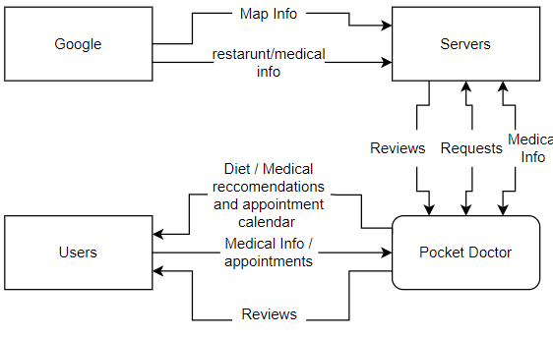

-ZW

**2.**

**Attached in repository**

**3.**

**Staff Organization: Team Structure**

Zachary - Team Leader

Samuel - Visual Design

Maksym - Backend Development

**4.**  We will make use of our slack channel and group workspaces to keep track of our work and changes made to the document. And also we will use these platforms as communication tools throughout our project.

* We also make use of our iMessage group chat as a way to reach out to one another fast.
* We do weekly check in the cafe
* We also use our sprint channel to keep track of our progress
* Our project schedule also keeps us up to date on what needs to be done and when it needs to be done. - SO

**RESOURCES**

Zach Wilson

Samuel Oduwole

Maksym LaRouche

Microsoft Vizio

Slack

Trello

GitHub

Microsoft Projects

Microsoft Breakout